Jasmina Durmishi – Activity Diagrams
AC_LMS_27 - Send Due Date Reminder:
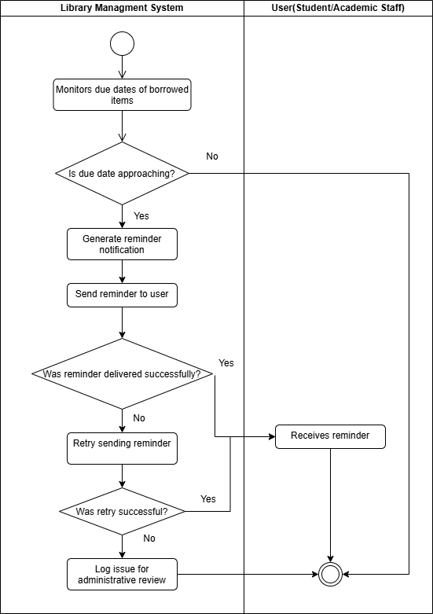
AC_LMS_28 - Send Overdue Notification:
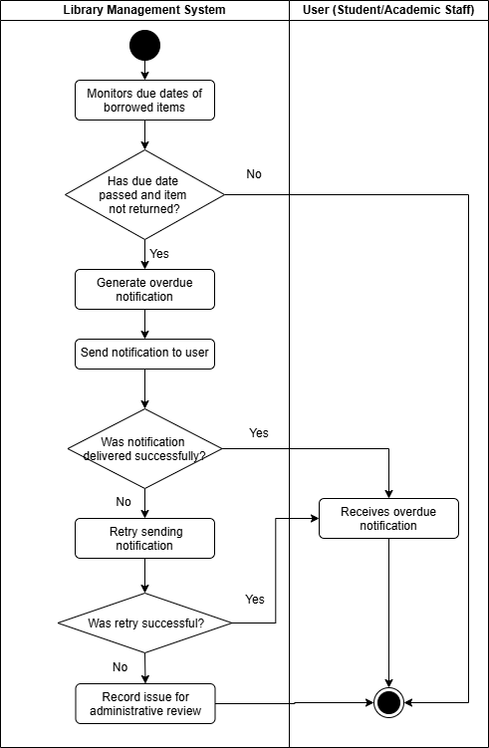

AC_LMS_29 - Send Borrowing Confirmation:
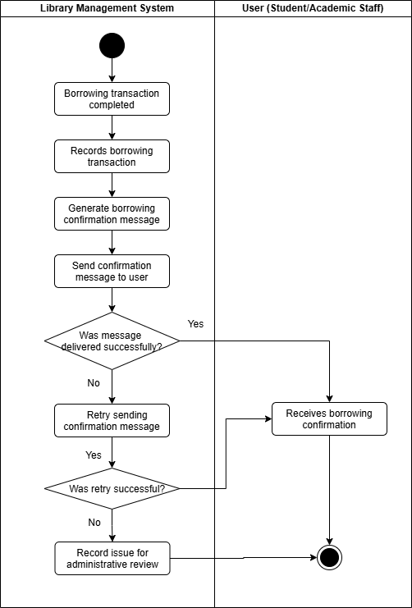

AC_LMS_30 - Send Return Confirmation:
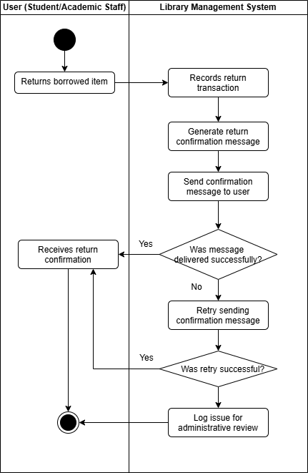

AC_LMS_31 - Send Fine Notification:
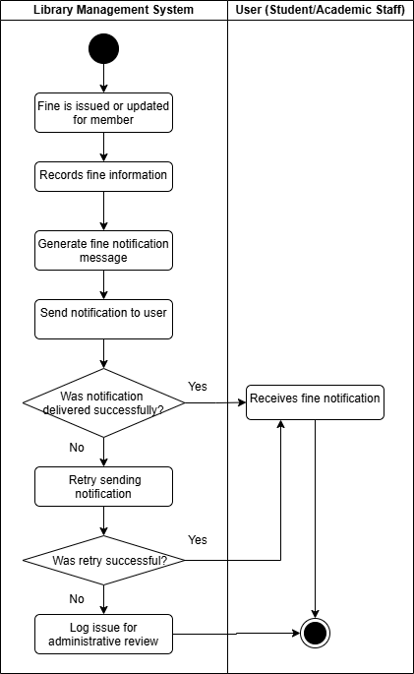

AC_LMS_32 - Deliver Alerts and Announcements:
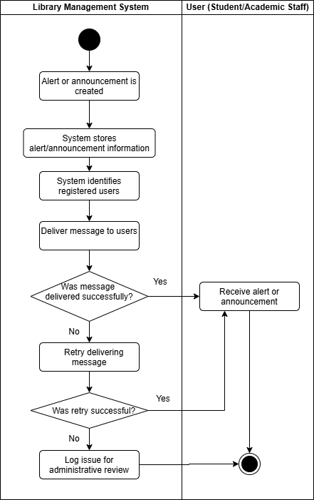

State Diagram – User (Students/Academic Staff)
